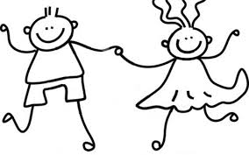

**Understanding the World**

The children will:

* remember and talk about significant experiences/events in their lives and the lives of their family and friends
* talk about similarities and differences in relation to family and friends
* learn about different occupations and ways of life
* develop an understanding of growth and changes over time
* talk about some of things they have observed

**Literacy**

The children will learn:

* to hear and say the initial sounds in words
* how to recognise some letters by sound
* how to orally blend and segment
* to begin to write and read simple words

**Mathematics**

The children will develop their:

* rote counting
* 1:1 counting using objects
* number recognition and number order
* shape knowledge
* sorting and classifying skills

**Expressive Arts and Design**

The children will learn:

* a repertoire of new songs
* to construct with a purpose in mind
* to create simple representations of events, people and objects
* to choose a particular colour for a purpose
* to engage in imaginative role play

**Physical Development**

The children will learn:

* spatial awareness
* to move freely with pleasure and confidence in a range of different ways
* to develop their pencil grip and control
* to form some recognisable letters
* how to safely access all of the resources

**Communication and Language Development**

The children will learn:

* to listen attentively to stories
* to respond to two part instructions
* how to use more complex sentences
* to build up vocabulary that reflects their experience

**Personal, Social and Emotional Development**

The children will learn:

* how to independently access their new environment
* to develop friendships
* to follow the new rules and routines
* to develop their confidence

**Topic WOW events!**

* Parents/carers will be invited in to our 'Getting to know you!' event.

**Main Topics**

The children will be supported to settle in and become familiar with their new environment.

Our umbrella topic is 'Marvellous Me' and the children will be able to select what they would like to learn about their topic.